**IOT LAB**

**Program No - 14**

**Program Title – SMART IRRIGATION**

**Aim – Design a irrigation system ( Potentiometer , Servo motor shaft).**

**Hardware Required -**

* Arduino Board
* Bread board
* Wires
* Potentiometer
* Micro servo

**Circuit Diagram –**

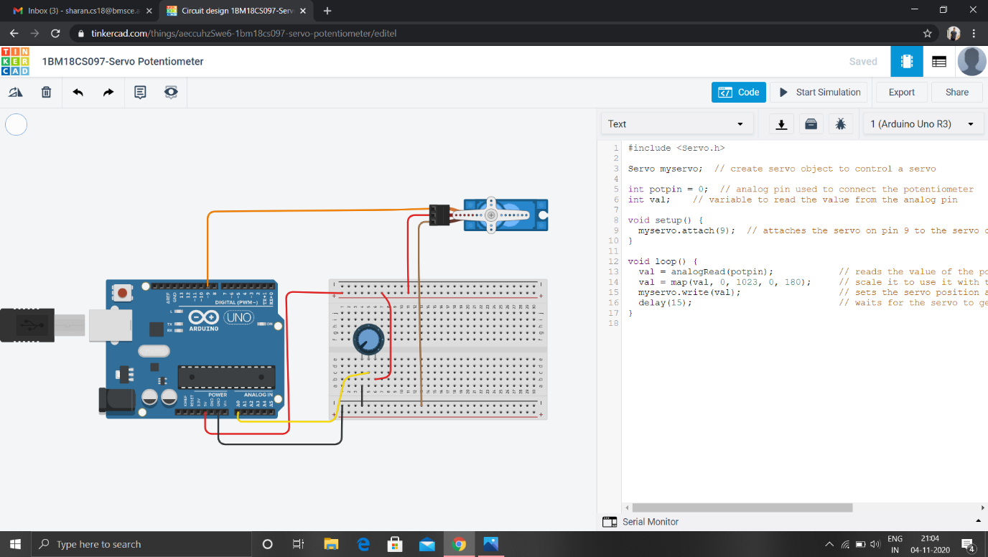

**Code –**

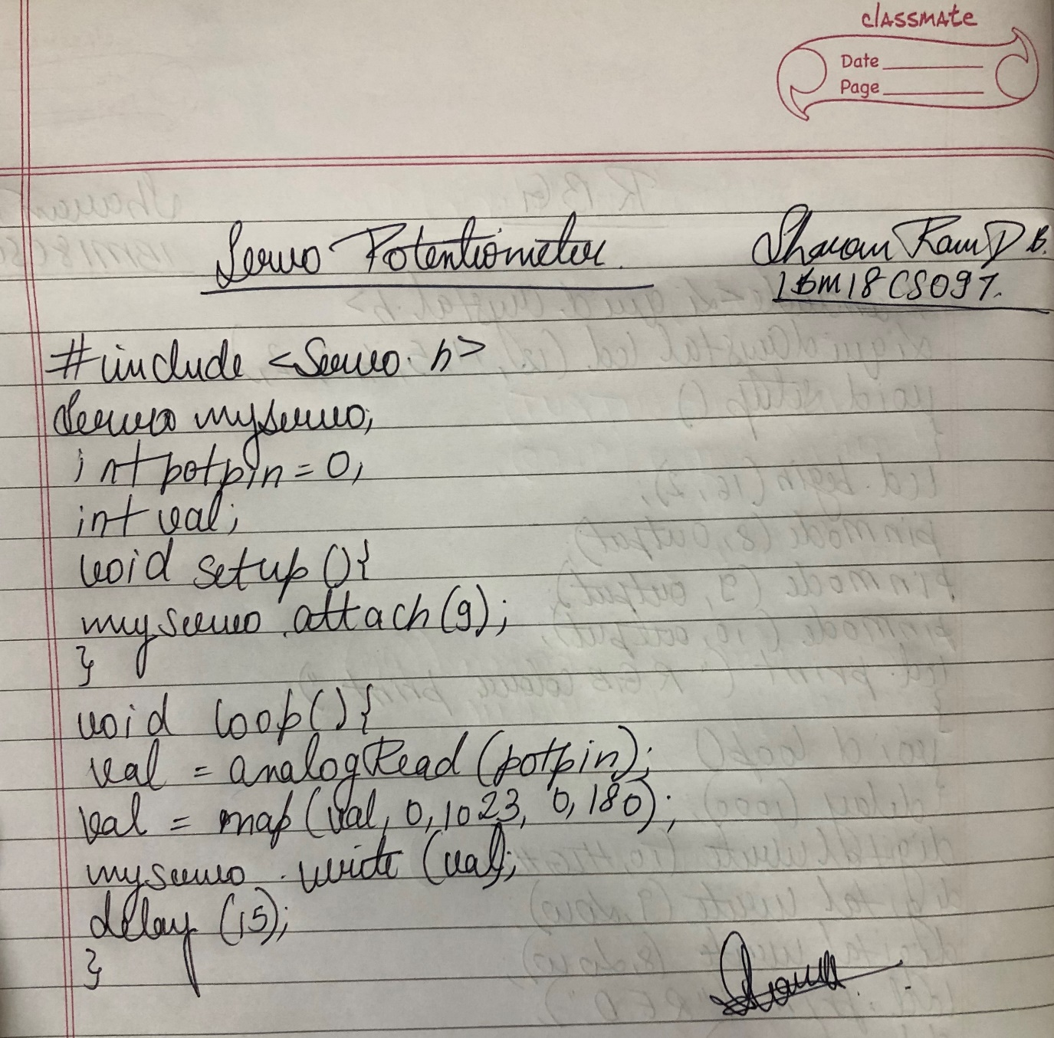

**Observation /Output –**

**The shaft rotates in the clockwise as well as anticlockwise as the potentiometer is rotated.**